AWS VPC TASK
Set up a VPC with an Internet gateway, create a public subnet with 256 IP addresses, a private subnet with 256 IP addresses, make a route table connecting the Internet gateway and the subnets, and launch a Linux EC2 instance by using the above VPC and public subnet.
To implement the given task, I have considered a simple project scenario say where a private MNC is requesting around 65,536 IPs for their upcoming insurance project. So, I have created a custom VPC with 10.0.0.0/16 CIDR. Inside this VPC, I have created a Public Subnet (10.0.1.0/24) and a Private Subnet (10.0.2.0/24), each having 256 IPs. To allow internet access for public resources, I attached an Internet Gateway, and for private resources, I configured a NAT Gateway. Finally, I launched a Linux EC2 instance in the Public Subnet using this setup.
S
VPC
10.0.0.0/16
65536 IP
EIP
NAT
SG
SG
PRIV RT
PUB RT
IGW

PRIVATE SUBNET
10.0.2.0/24
256 IP
PUBLIC SUBNET
10.0.1.0/24
256 IP

- Go to AWS Console → VPC → Create VPC → Select VPC only→Name: Project-A →IPv4 CIDR Block: 10.0.0.0/16→Tenancy: Default→ finally click on Create VPC.
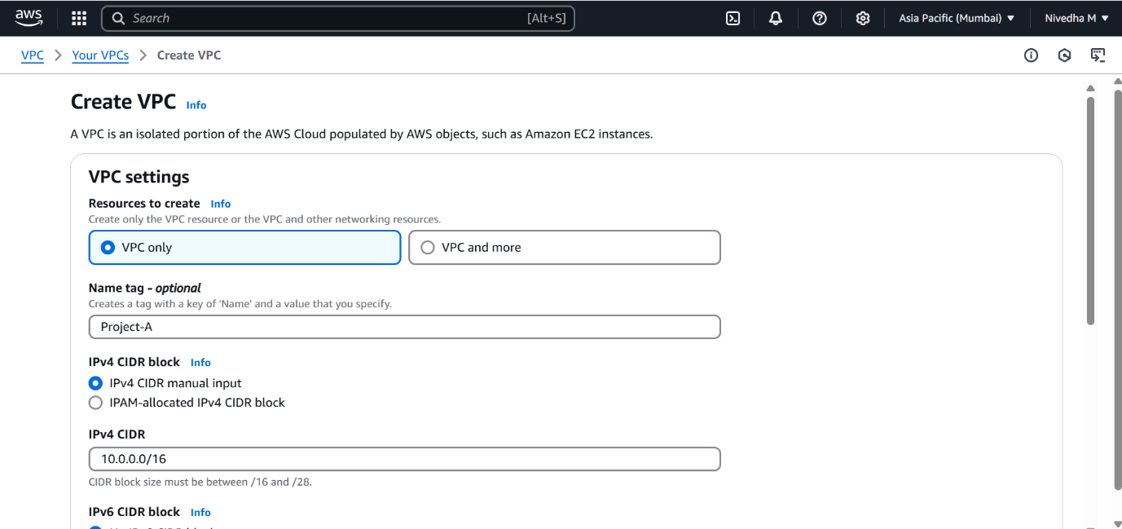
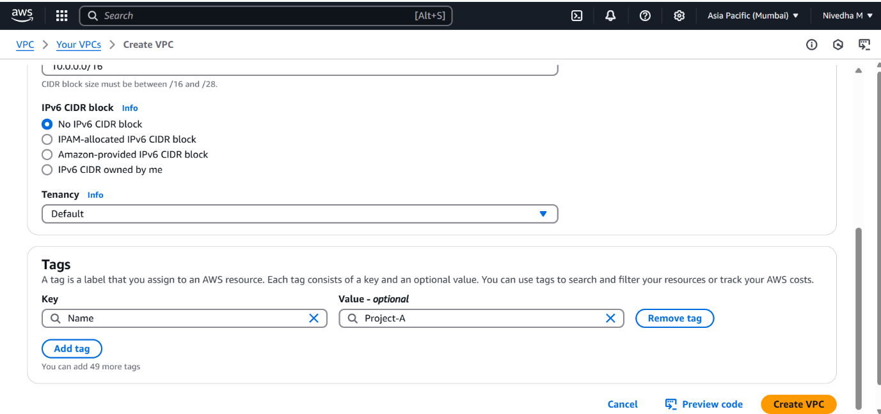
- Create Subnet→ Public Subnet →Name: Public Subnet-Project-A →CIDR Block: 10.0.1.0/24→Availability Zone: ap-south-1a.
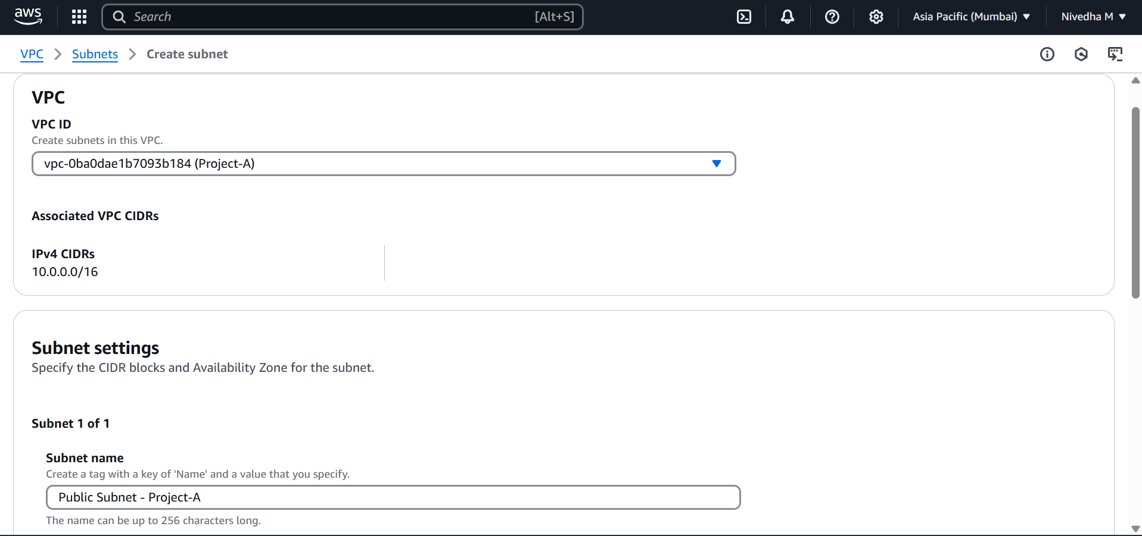
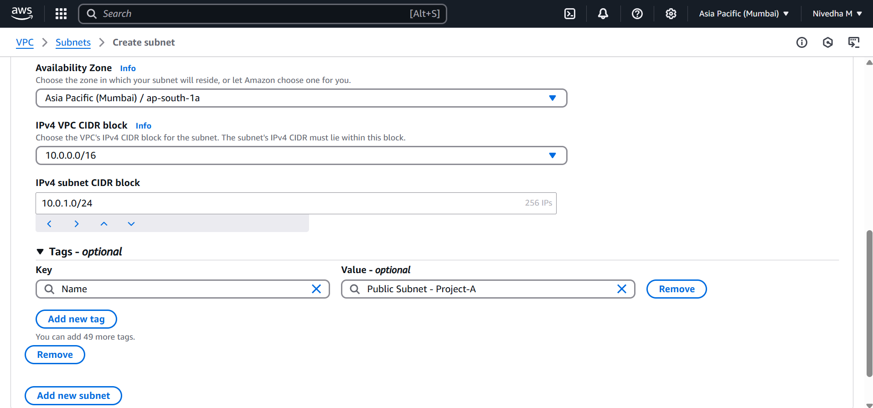
- Now create private subnet→ Private Subnet →Name: Private Subnet-Project-A→CIDR Block: 10.0.2.0/24→Availability Zone: ap-south-1b.

- Create and Attach Internet Gateway (IGW)→ For that go to → VPC → Internet Gateway → Create→Name: IGW-Project-A→Attach to created VPC(Project-A)→Create IGW

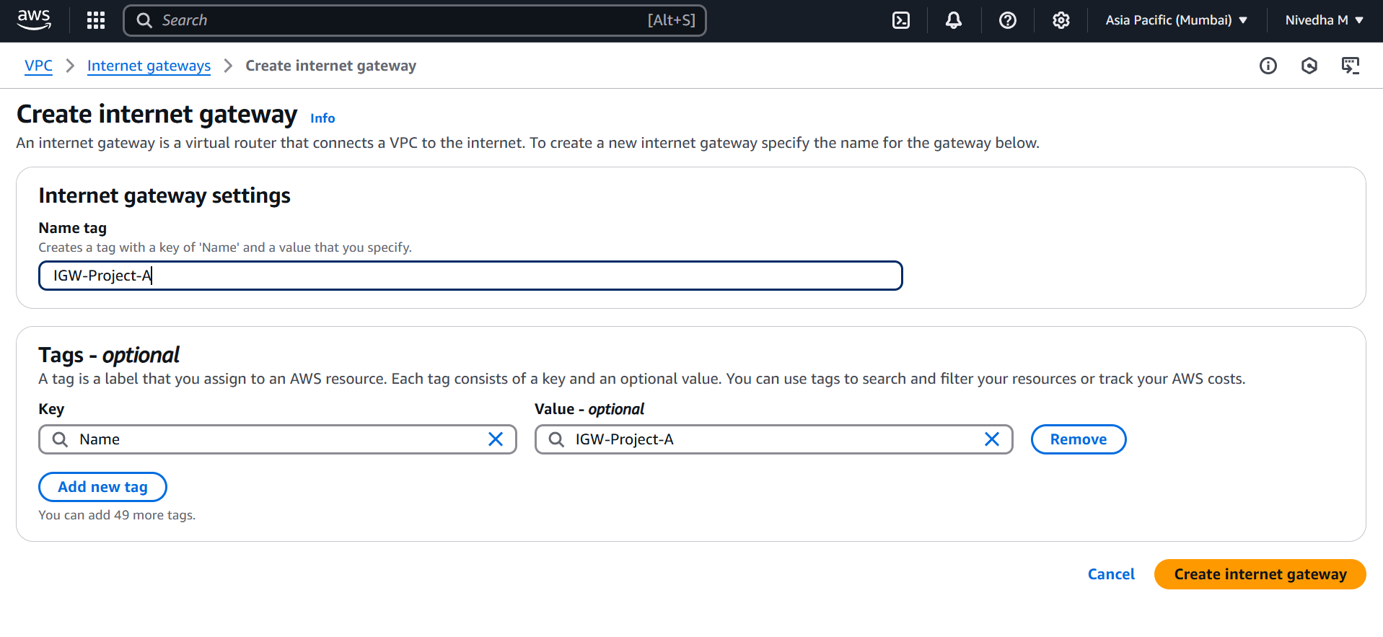
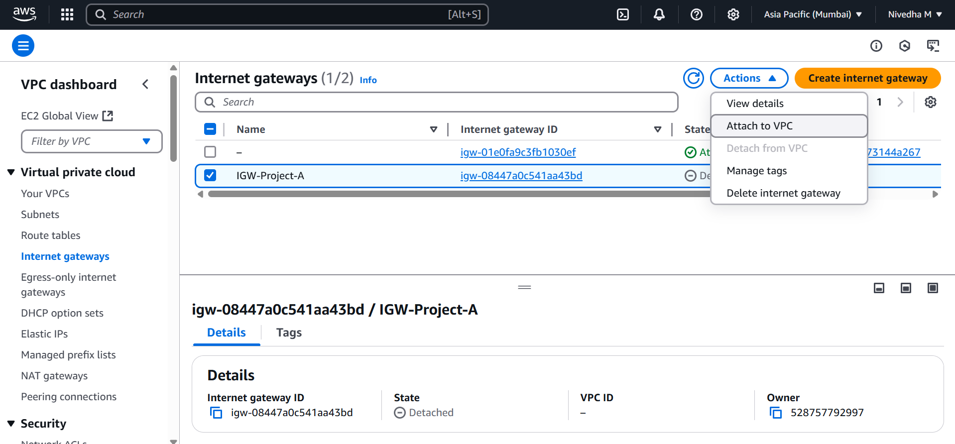
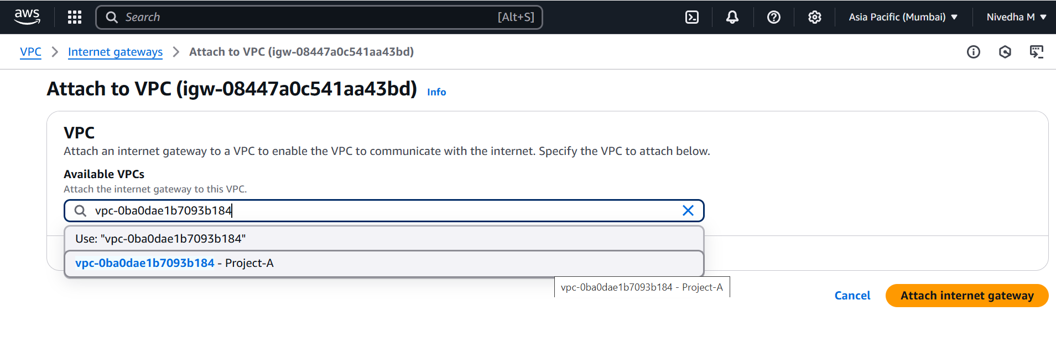

- Create Route Tables → Give Name- Public-RT-Project-A → select the created VPC(Project-A)→ select create route table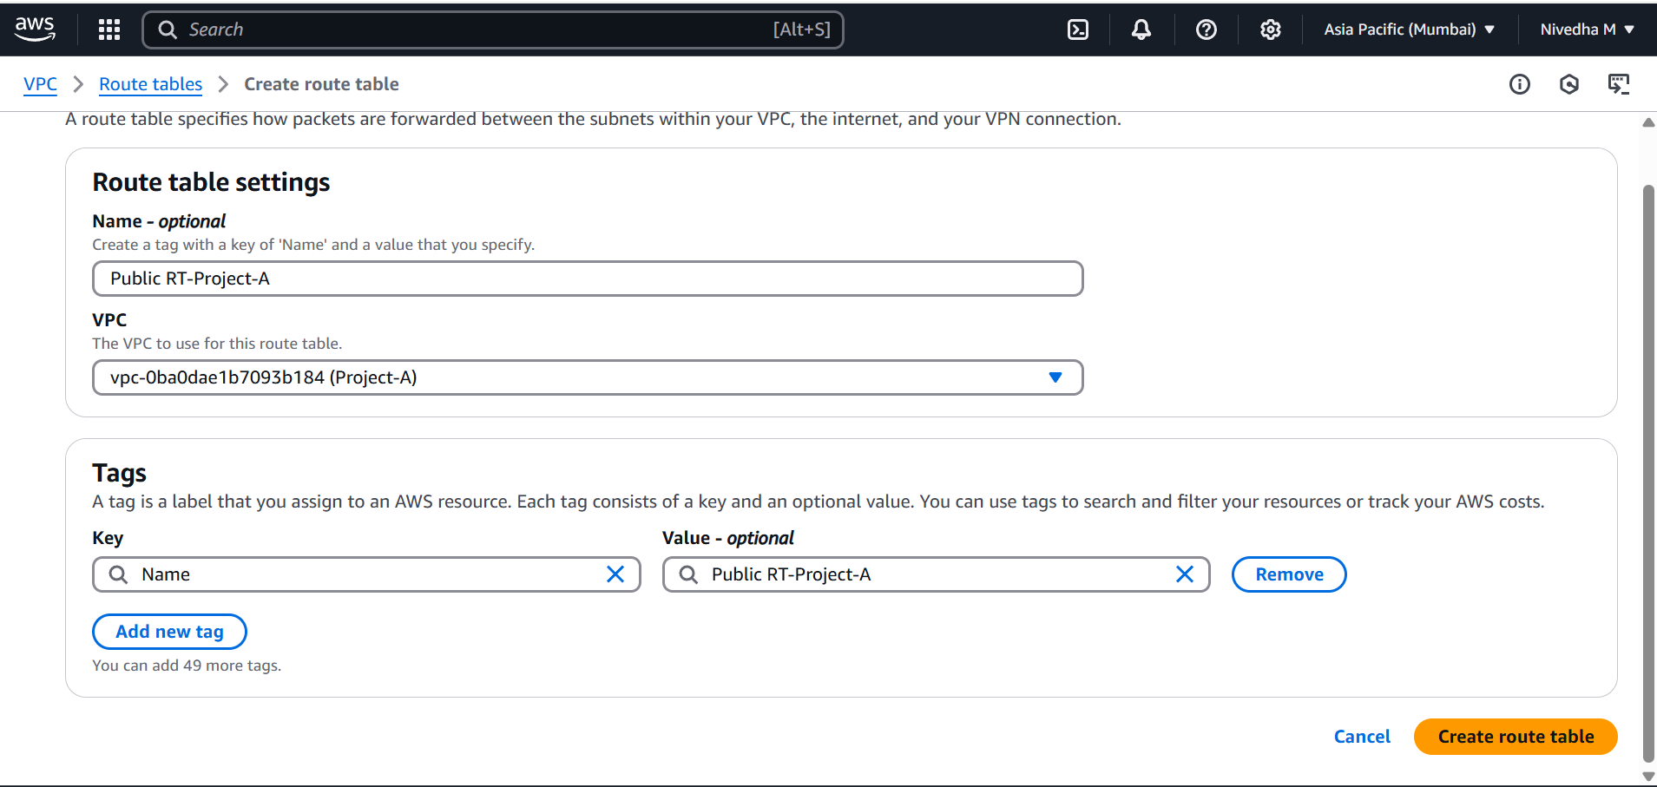
- Create Route Tables → Give Name- Private-RT-Project-A → select the created VPC(Project-A)→ select create route table.

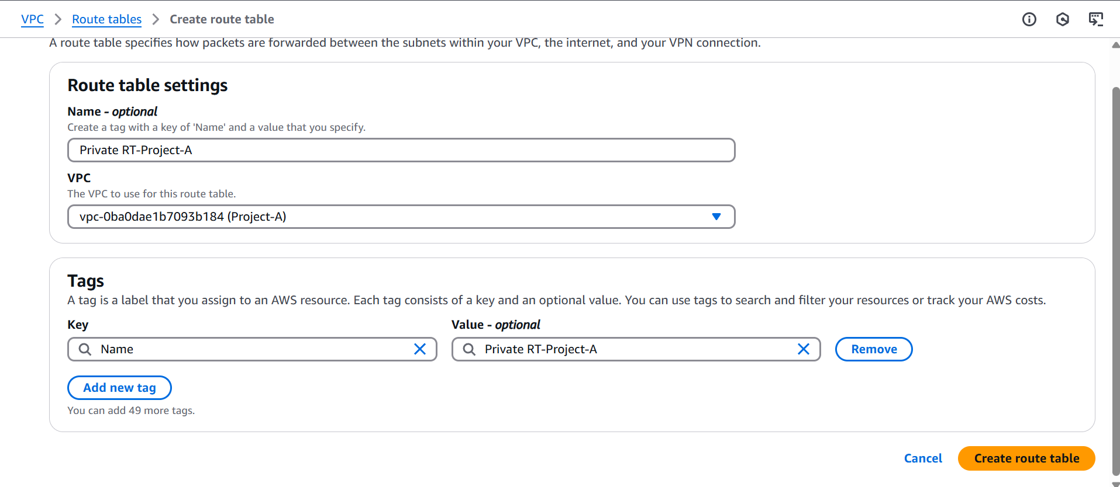
- Now in the Route Table → Select Public RT→ Click on Subnet Associations → select Edit subnet associations. In the available subnets, select Public subnet→ Save association. Repeat the same for Private subnet also.
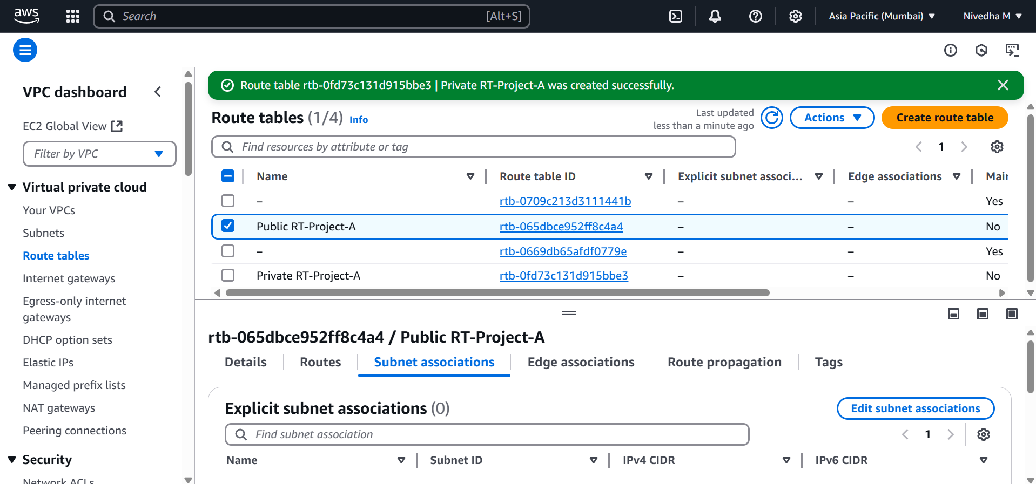
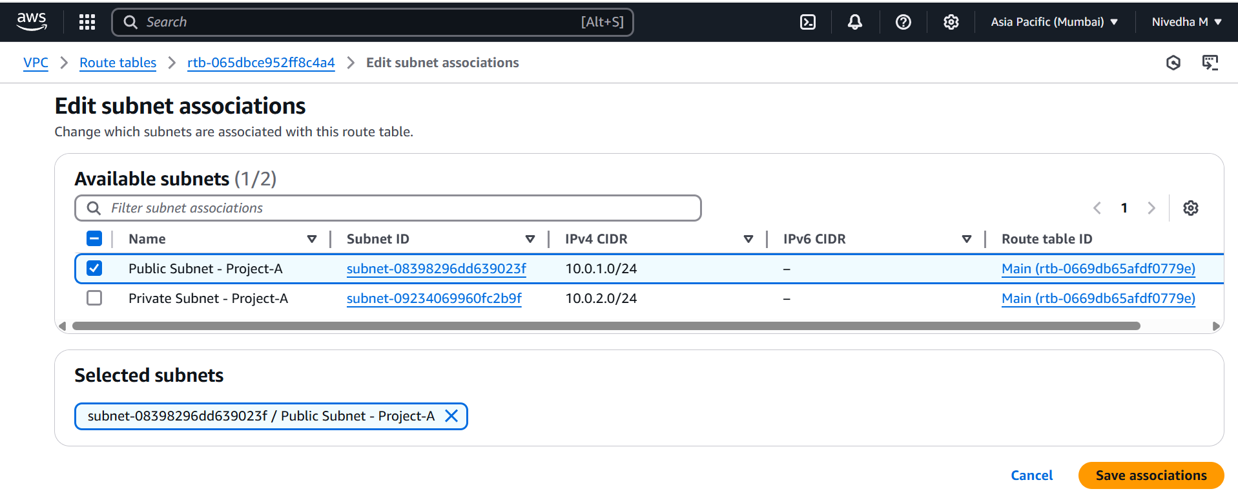
- Again, in Route Table Select public RT→ go to the Routes → Edit-> Routes →Add routes→0.0.0.0/0→ select IGW and select the created IGW→ save.
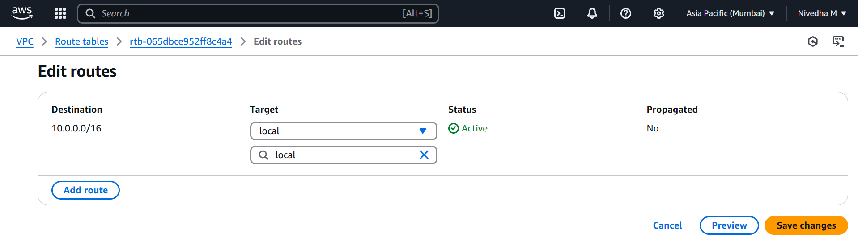
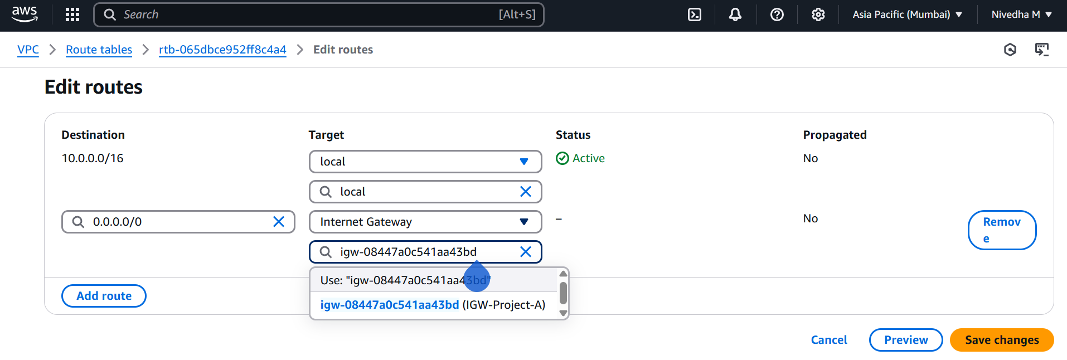
- Create Security Group→ give SG name: Public SG-Project-A→ VPC : select the created VPC(Project-A)→ Inbound rules: add SSH HTTP HTTPS RDP→ Outbound rules: all traffic→ create SG. Once created, Note down the public SG id for reference.

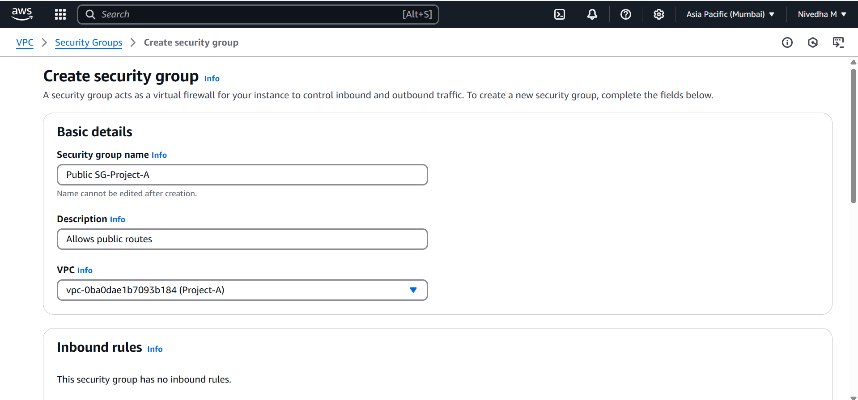
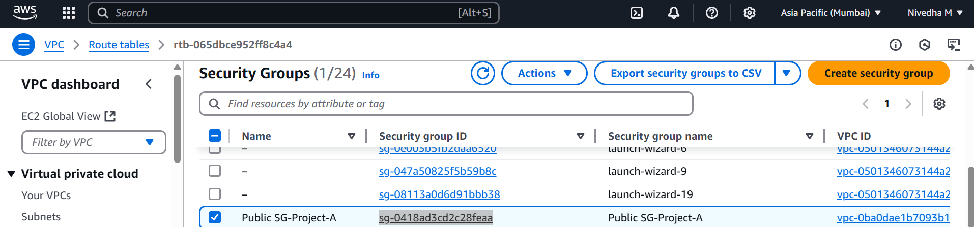

- Repeat the same for private SG→ Private SG-Project-A→ Select the VPC created (Project-A) → Inbound rules→ select All TCP→ in Source Scroll down little bit and select the created public SG→ Save.
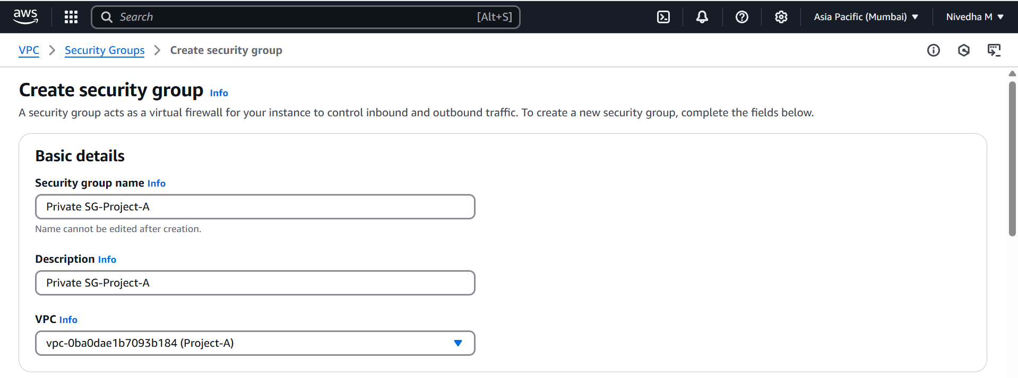

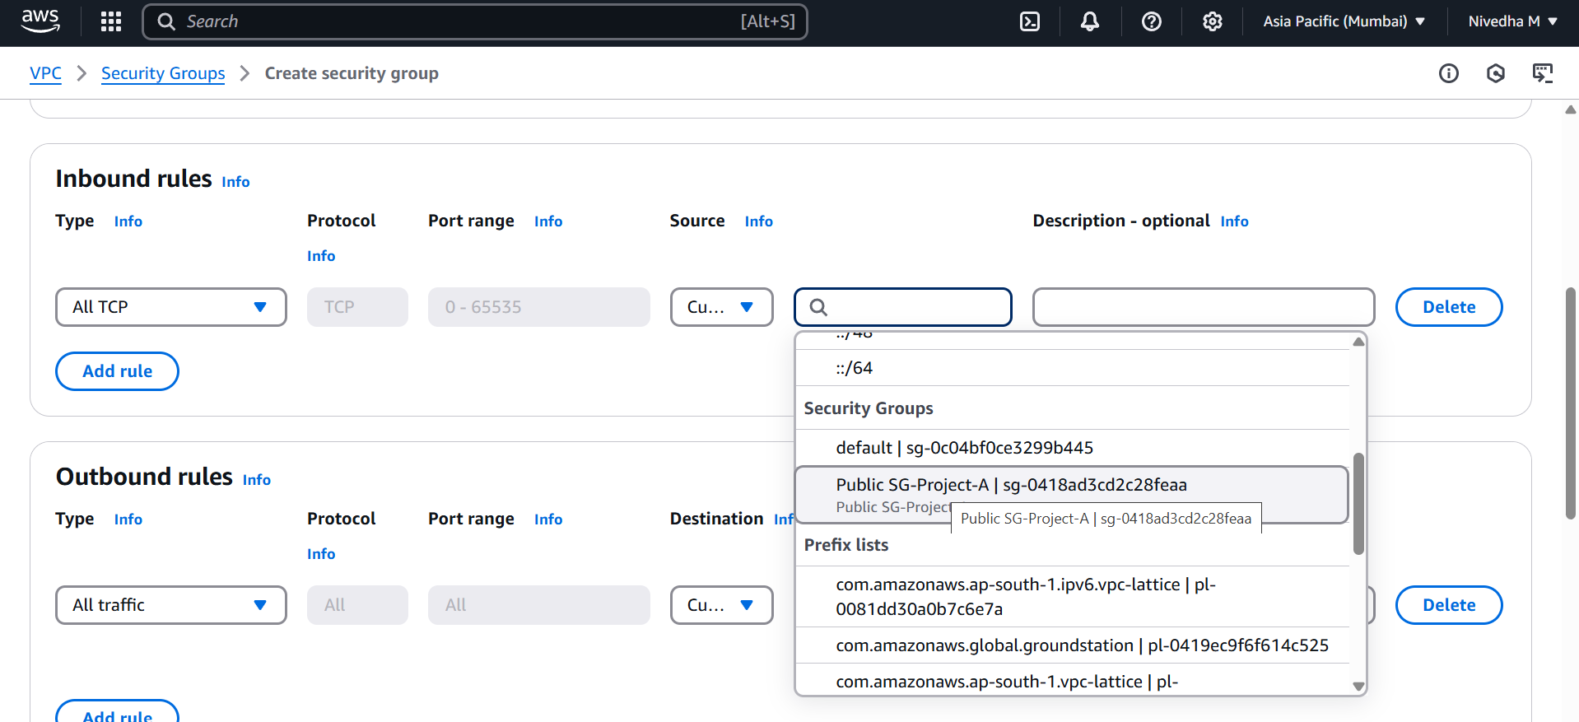
- Create a EC2 instance → select Linux AMI→in network settings select VPC created→ select the Public Subnet→ Auto assign public IP:Enable→ SG click on existing SG → select public SG→ Launch.
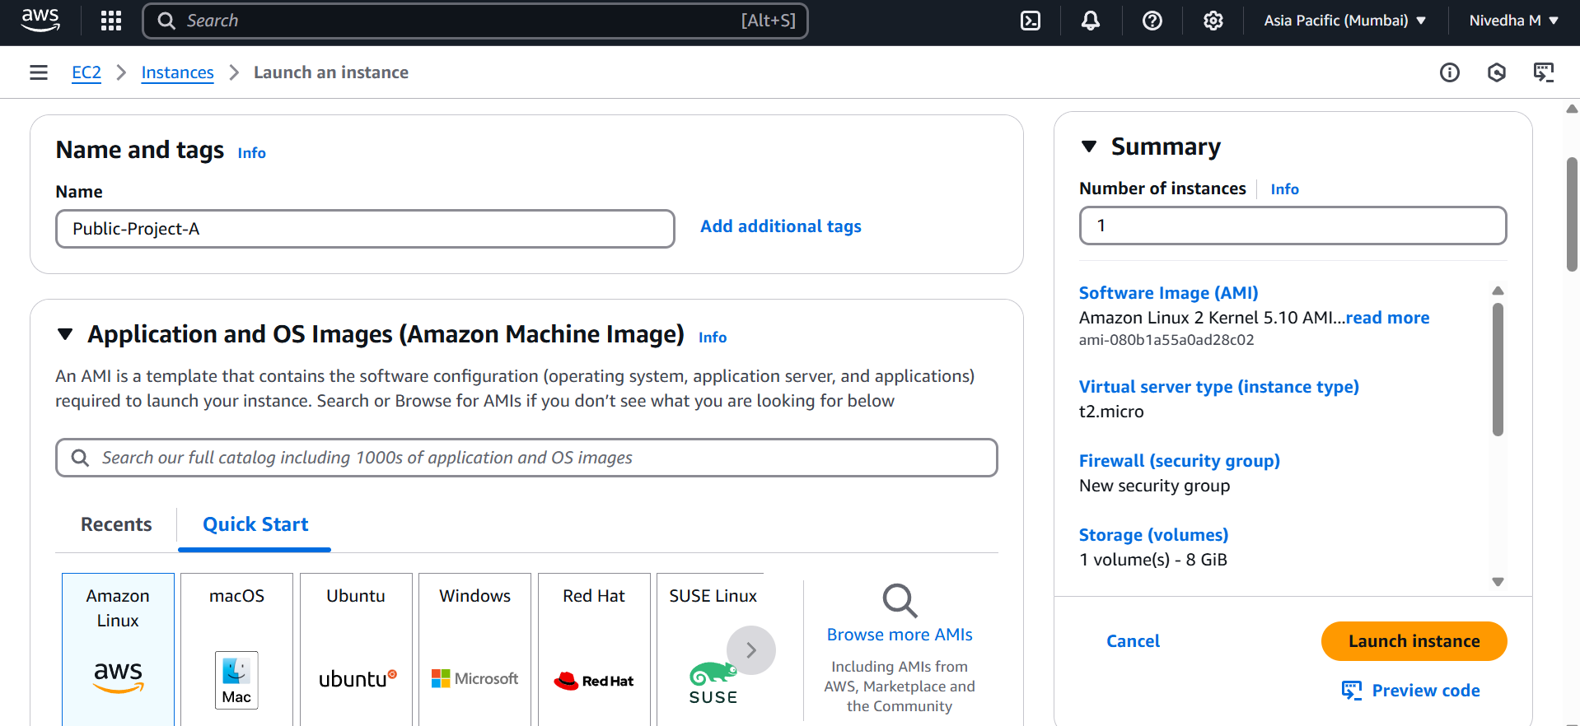
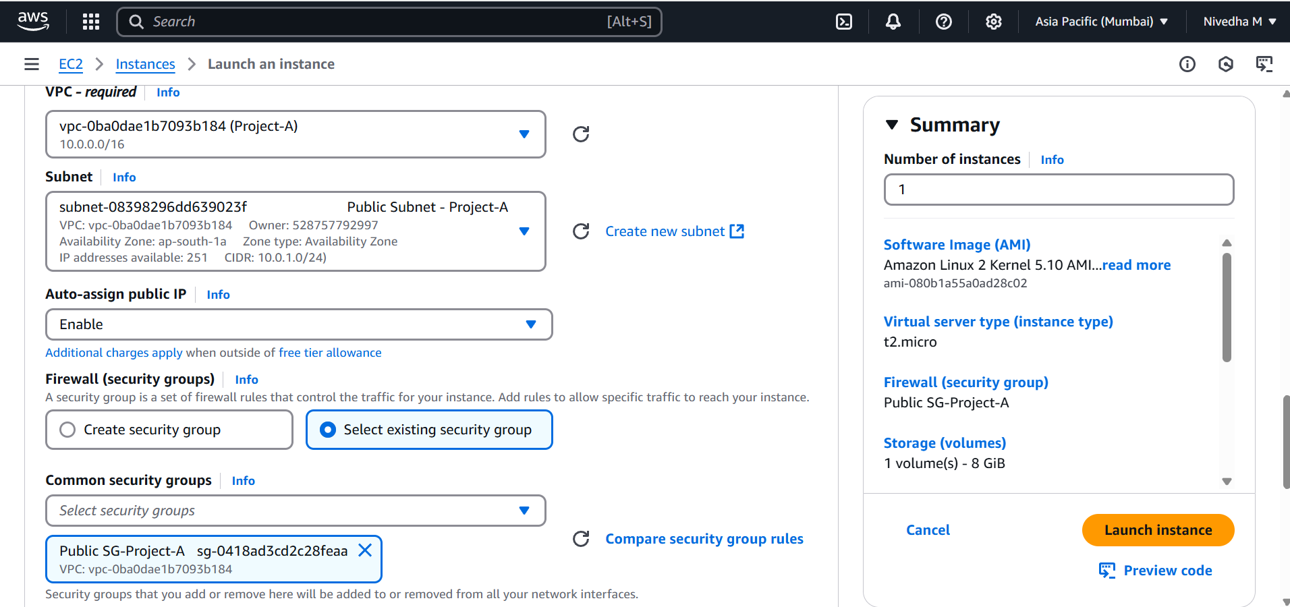
- Repeat the same for creating another in private EC2. In subnet select private subnet→ auto assign public IP: Disable → SG click on existing SG→ select public SG→ Launch.

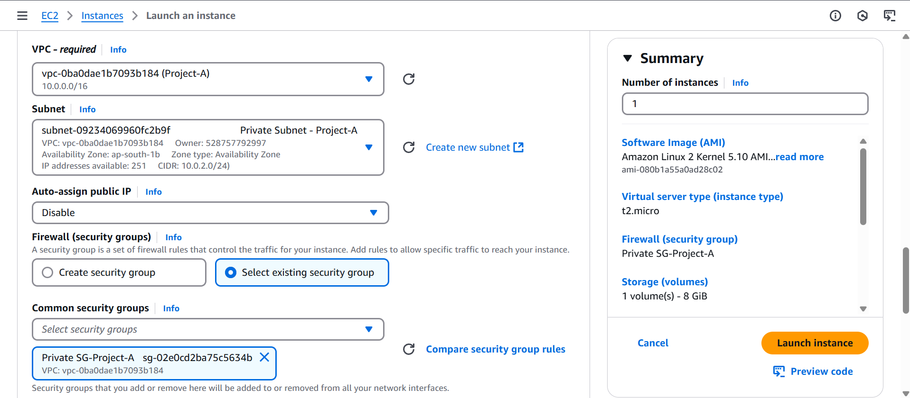

- Now if you login into Public EC2 with public IP and check if you can access the internet from inside.
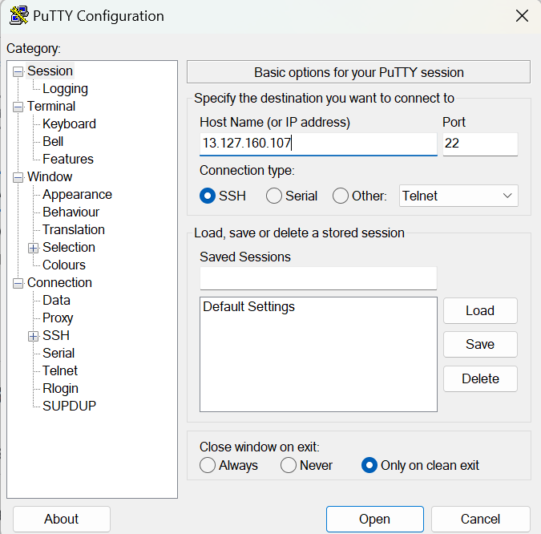

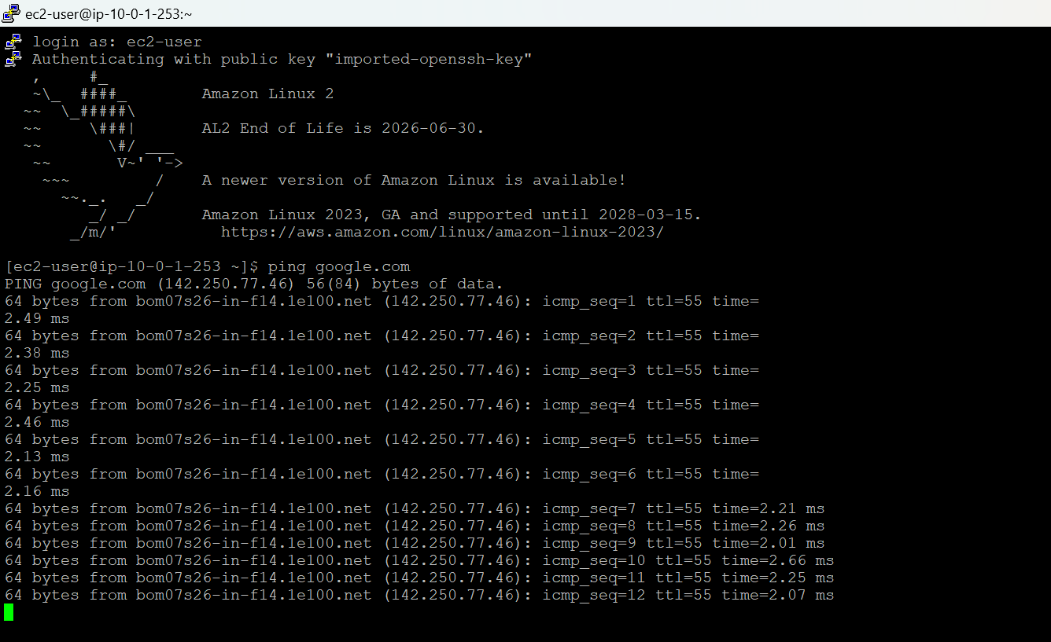

- To get internet in private EC2 machine we need to Create NAT. Goto NAT Gateway→ create→ Name: NAT-Project-A→ select the public subnet(source for the internet)→ Allocate Elastic IP→ create NAT Gateway.
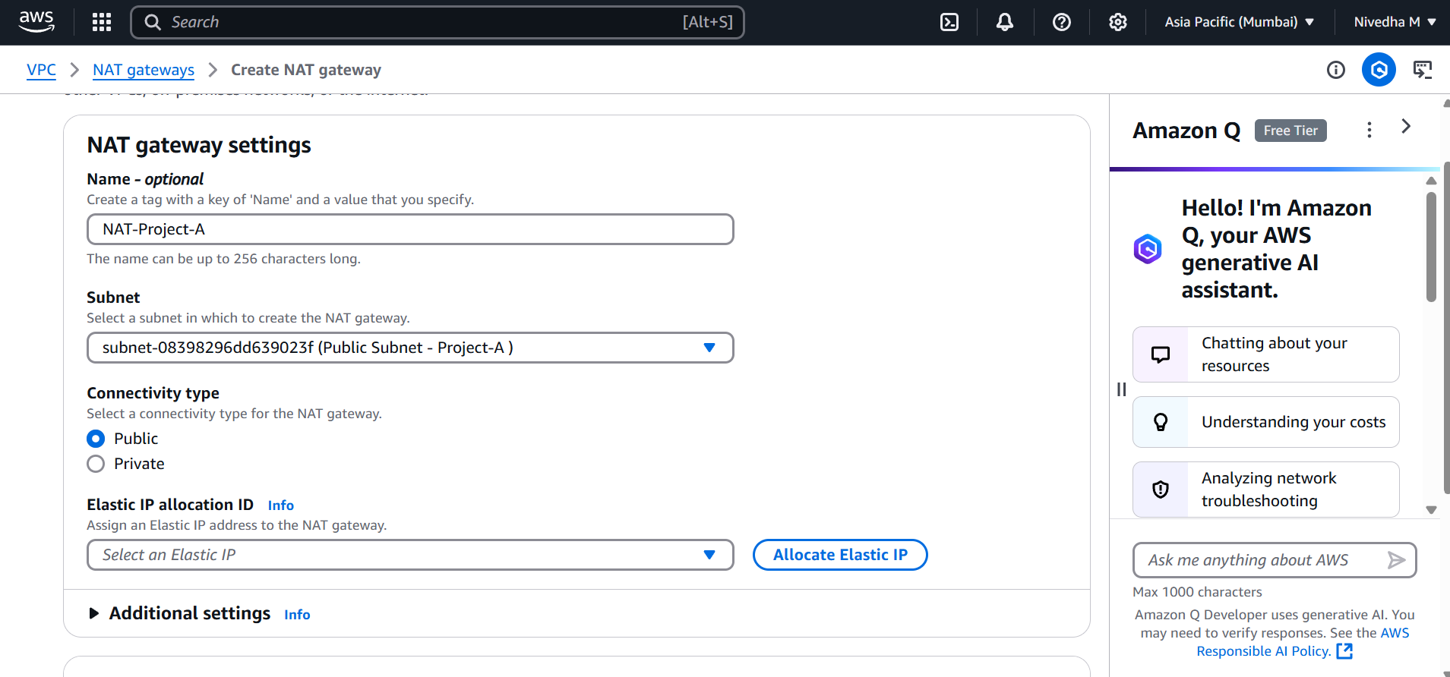
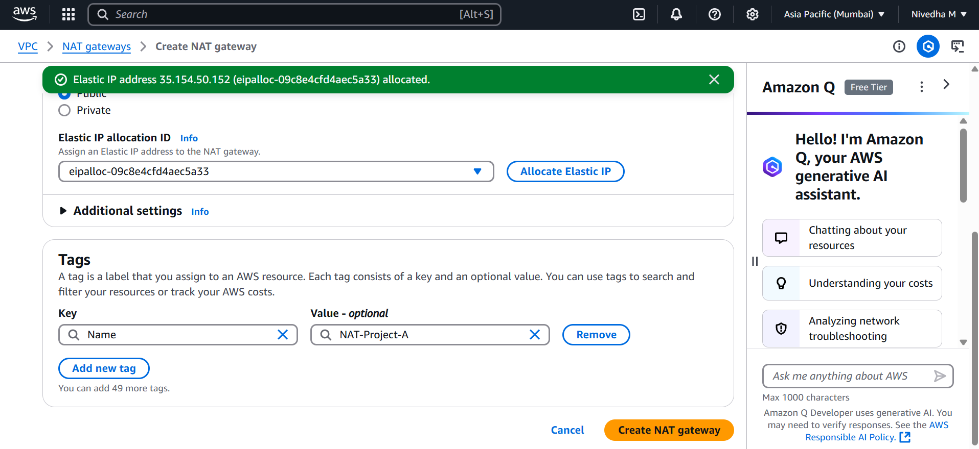
- Now go to VPC→ Select Route Table→ select Private RT→ Rotes→Edit Routes: 0.0.0.0/0→ in target select NAT Gateway and select the created one→ Save.
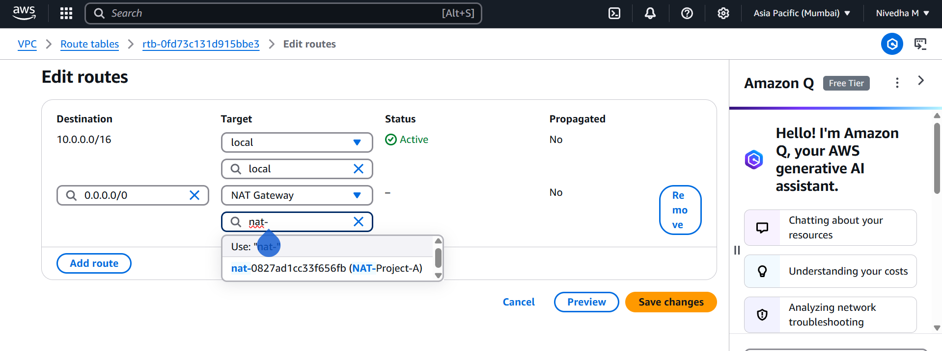

- Now to login in to private EC2 we can use SSM. Make sure our local PC is installed with SSM plugin.
- Go to AWS console: IAM→ Roles→ Create Roles→ Trusted entity → EC2→Attach Policy → AmazonSSMManagedInstanceCore →Role name: SSM-Access-Role→ Create.
- Now got to EC2→ Select Private EC2 → Actions → Security → Modify IAM Role → Choose SSM-Access-Role → Update.
- Then Open Powershell→ type AWS configure→ it will ask for Access key and secret access key. Click on AWS Console right top corner → Account Name / Email ID → Select → Security Credentials→ Scroll down → Access Keys section varum→Click → Create Access Key.
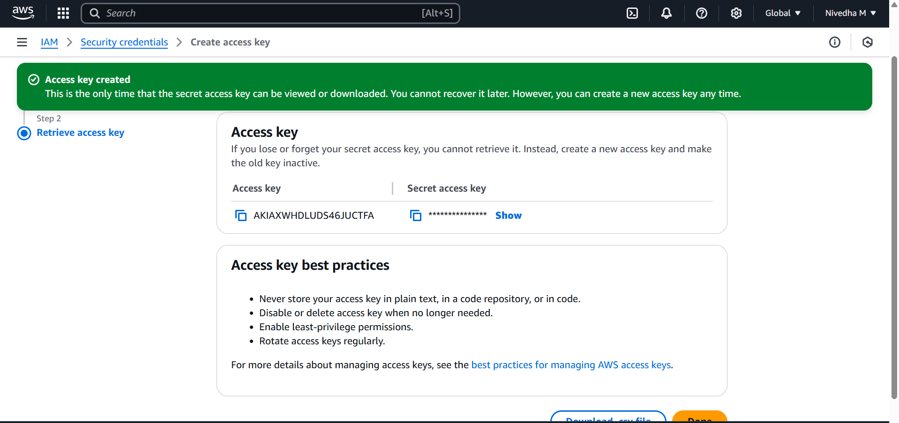
- Then type aws ssm start-session --target i-0857444c77ad6eb84 --region ap-south-1. Now we are into private EC2 instance, and we are accessible to internet.
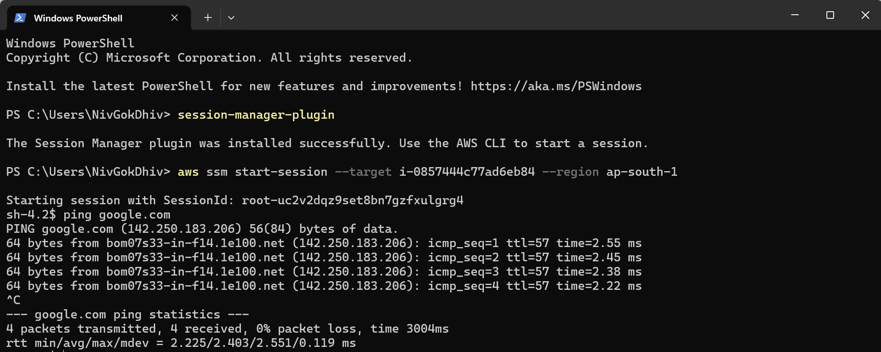

Troubleshooting Steps

- While logging in to Private ec2 via powershell I got the below errors
PS C:\Users\NivGokDhiv> aws ssm start-session --target i-0857444c77ad6eb84 --region ap-south-1 SessionManagerPlugin is not found. Please refer to SessionManager Documentation here: http://docs.aws.amazon.com/console/systems-manager/session-manager-plugin-not-found PS C:\Users\NivGokDhiv>
- So I downloaded plugins.

- Again I faced
PS C:\Users\NivGokDhiv> session-manager-plugin session-manager-plugin : The term 'session-manager-plugin' is not recognized as the name of a cmdlet, function, script file, or operable program. Check the spelling of the name, or if a path was included, verify that the path is correct and try again. At line:1 char:1 + session-manager-plugin + ~~~~~~~~~~~~~~~~~~~~~~ + CategoryInfo : ObjectNotFound: (session-manager-plugin:String) [], CommandNotFoundException + FullyQualifiedErrorId : CommandNotFoundException
- To rectify it I added the environment variables manually.
- Right click This PC → Properties → Advanced system settings → Environment Variables → System Variables → Path → Edit → New(Add→ C:\Program Files\Amazon\SessionManagerPlugin\bin)→ Save & Ok.

- Close the powershell and open a new window→ and check again→session-manager-plugin

